|  |  |
| --- | --- |
| COURSE NAME: | FINANCE & ACCOUNTING WITH ZOHO BOOKS |
| PROJECT TITLE: | Travel trax and tours |
| PROJECT SUBMITTED TO: | SMART INTERNZ |
| YEAR: | 2023-2024 |
| DEPARTMENT: | COMMERCE |
| SEMESTER: | V |
| TEAM ID: |  |
| MEMBERS OF THE GROUP: | Register No. M.Vanmathi (Team leader)  1321151039 |
|  | S.Swetha - 1321151038 |
|  | V.Vinitha - 1321151040 |
|  | K.Vishnu priya - 1321151041 |
| GUIDED BY: | MRS M.PRIYANKA B.COM., M.COM.,M.PHIL  MS.S.GOWSALYA  B.COM(CA).,M.COM.,M.PHIL |
| SPOC NAME: | Ms. K. Elizabeth, M.Sc., M.Phil., B.Ed., Assistant  Professor |
| Team id | NM2023TMID10494 |

Introduction :

Travel refers to the act of moving from one location to another. This

can refer to long-distance, short-distance, overseas, domestic, and various other forms. Crucially, travel also includes both round trips and one-way journeys, and it covers a wide variety of different travel purposes. The travel industry, therefore, refers to the numerous aspects of the wider service industry which cater to the needs and desires of those who have traveled from one part of the world to another.

Overview :

Tourism is generally regarded as traveling to a different location for business or pleasure purposes. However, it has quite a specific definition: traveling to another environment for at least 24 hours, but for no longer than one year, for purposes related to business or leisure

The travel and tourism industry is one of the largest and most competitive in the world, and this means that tourism businesses can live or die based on the quality of their marketing efforts. In particular, companies like hotels, airlines, travel agents, tour operators, and car rental services must use the latest marketing methods to stand out.

Preparation and maintenance of Zoho books for travel trax and tours

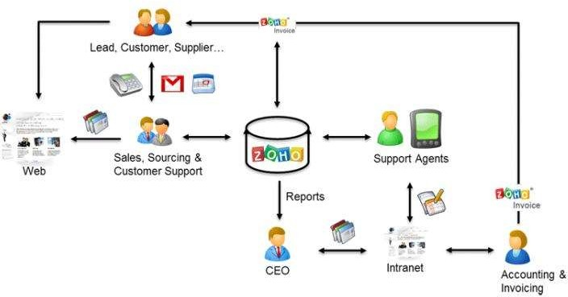

Purpose :

The most common purpose of traveling is for business. This includes traveling

to attend corporate meetings, to visit business locations, and to take part in professional development. Business travel helps to support the tourism and hospitality industries, such as transportation, hotels, and restaurants.

It helps educate the traveller; provides funds for conservation; directly benefits the economic development and political empowerment of local communities, and fosters respect for different cultures and for human rights.

Result

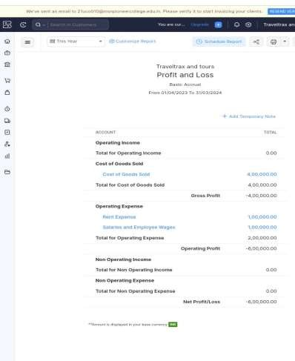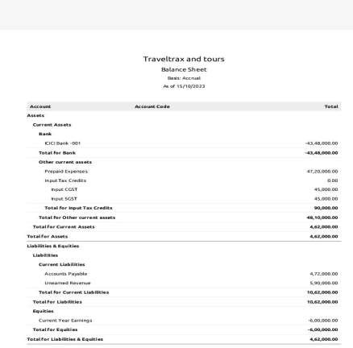

Advantages

Economic Growth:By generating foreign exchange revenues, countries can pay off debt or finance imports, leading to better economic Growth. Additionally, it may result in the establishment of new companies and markets, which impacts the economy as a whole. Tourism also led to the creation of jobs, thus affecting the country’s GDP as a whole.

Social Benefits

The understanding and preservation of cultural heritage can be enhanced by tourism. Tourism can help influence the social engagement and knowledge of communities. Tourism lets people see monuments, palaces, and other historical places, exposing them to different cultures. This tells people about culture and values that help break stereotypes and misconceptions. This results in greater inter- community empathy, understanding, and respect.

Education And Personal Growth

Tourism lets you learn about the place, its culture, and its heritage. This makes you sound knowledgeable. Moreover, when you are familiar, there is tremendous potential for personal Growth. Personal Growth also leads to better business opportunities.

Creation of Jobs

Tourism led to the creation of jobs. The country’s locals can find jobs at lounges, bars, casinos, hotels, parks, zoos, entertainment points, and other places. This helps people to earn a decent income and live their lives quickly.

Breaks the Stereotypes

When you visit another nation and see its traditions and religious beliefs, you can learn about new perspectives and customs. This helps build a broader perspective and brings you closer to people from other communities. Moreover, once you feel their culture, it all breaks your myths and notions about different cultures.

Brainstroming

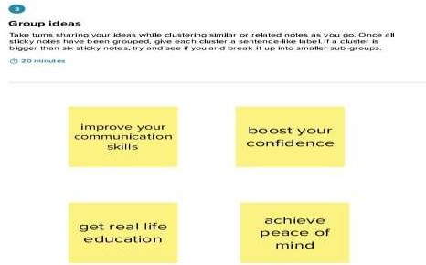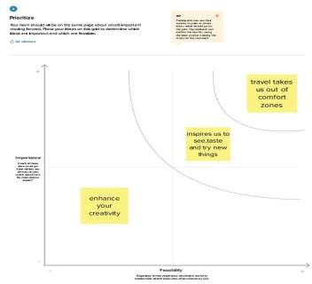

Brainstroming

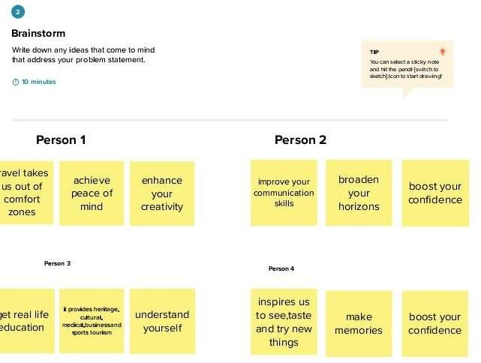

Disadvantage

Degradation of the Environment :

When millions of people travel to a destination, it leads to a high tourist influx at the goal. This is because when so many people travel to a place, it increases the number of vehicles, leading to a rise in carbon emissions. Moreover, when so many tourists are present at the same site, it can also increase the garbage, leading to the generation of a massive quantity of non-biodegradable waste.

This impacts the environment badly.

Depletion of Natural Resources

Tourism can lead to the depletion of natural resources. When tourists come to a place, they eat food, drink water, and even use fuel to travel across the area. This can create pressure on countries that have limited access to such resources

Over Dependence on tourism

When countries consider tourism their primary sector for Growth and development, they neglect other industries. This can lead to several problems, as tourism can get poorly affected during natural disasters, war, or unrest in the country. Moreover, if the government is forced to close its border, the country’s stability can also be impacted for longer.

Seasonal Nature

Some places are best visited during a specific time of the year. In such scenarios, such countries face many issues before and after the period as people’s earnings reduce, and they must look for alternate sources to earn money. Moreover, several people lose their job due to the low influx of tourists, which impacts their livelihood badly.

Application

With the e-commerce business growing, every business needs a mobile application.

Long gone are days when people used maps, guides and waited for reservations. The travel and tourism industry grew a lot in a few years. Just like any other industry, it wants attention and efficient technological advancement

Empathy map

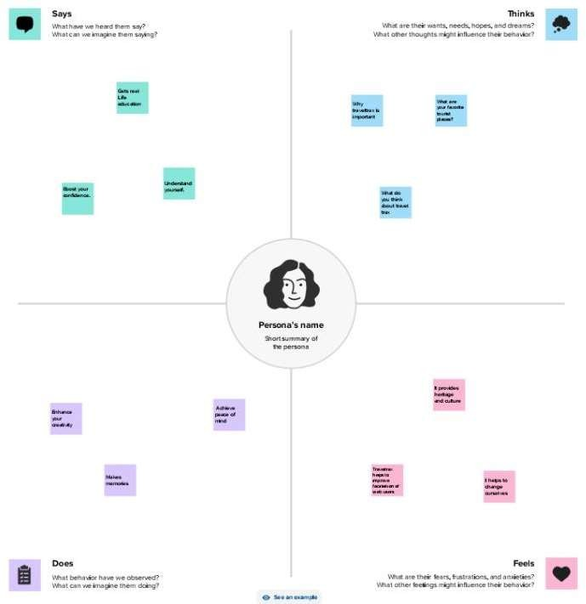

Application

Brand-Awareness. Having a travel application gives companies a chance to spread awareness about their brand irrespective of their geographical location.

Moreover, tourists can get all the information they need directly from the application

Conclusion

In conclusion, travel and tourism have significantly shaped the global economy and brought people together from different cultures and background

India has the potential to become one of the top tourism centers in the world.

With its cultural diversity, historical landmarks, adventure tourism opportunities, medical tourism facilities, and warm hospitality, India has a lot to offer to tourists.

Future scope

n 2020 alone, the travel and tourism industry lost $4.5 trillion in GDP and 62 million jobs - the road to recovery remains long.The World Economic Forum’s latest Travel & Tourism Development Index gives expert insights on how the sector will recover and grow.

We asked four business leaders in the sector to reflect on the state of its recovery, lessons learned from the pandemic, and the conditions that are critical for the future success of travel and tourism businesses and destinations.